Chapter 5, Problem 70

Determine v_{o} in the op amp circuit of Fig. 5.96.

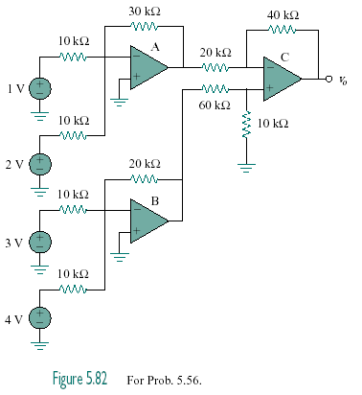
Figure 5.96
For Prob. 5.70.

